

Geophysical Research Letters
Supporting Information for
First observation of quenched Davemaoite to Ambient Conditions: its Electron Diffraction Pattern
N. Miyajima¹, L. Wang¹ and T. Katsura¹
¹Bayerisches Geoinstitut, University of Bayreuth, D-95440 Bayreuth, Germany
Corresponding author: Nobuyoshi Miyajima (Nobuyoshi.Miyajima@uni-bayreuth.de)

Contents of this file

Text S1 to S6
Figures S1, S2.1, S2.2, S3, S4.1, S4.2, S4.3, S5 and S6.
Tables S1 and S2

Introduction
Here we provide Supporting Information of the following analyses, Text S1: XRD data of bridgmanite (Bdm), Text S2: The refinements of the lattice parameters of Bdm, Text S3: The refinements of the lattice parameters of davemaoite (Dvm) in the electron diffraction patterns, and Text S4: The symmetry of davemaoite in selected area electron diffraction to analyze the extinction rule of Pm$\overline{3}$m in Dvm, and Text S5: A HAADF-STEM image of the Iris-1272 sample showing an amorphization process of crystalline domains of Dvm. Text S6: The estimation of a residual pressure in the recovered sample from the high-pressure experiment (Iris-1272).
Table S1 shows 10 individual d(400) spacings and the standard deviation in davemaoite (Dvm) for the refinements of the lattice parameters. Table S2: volume and molar volume of Dvm at ambient conditions in the literature for comparison.

Text S1. The refinements of the lattice parameters of Bdm in the micro-focused beam X-ray diffraction pattern

The obtained X-ray diffraction pattern (Fig. S1) is not good enough to get a proper intensity due to a reflection geometry in a surface polished specimen. So, I could not use Le Bail or Rietveld method to fit the full pattern but used a structure factor weighted method. The obtained lattice parameters are as follows.
a = 0.48093(4) nm
b = 0.50021(5) nm
c = 0.7038916(6) nm,
Molar Volume = 25.49 cm³/mol.

The errors in the refinement is unreliable too high, it might be just originated from the mathematics in treating many peaks, but the accuracy of the value is high because of a correction on the measuring angles based on an external standard of silicon.
The lattice parameters are consistent with a Fe, Al-bearing Bdm with a composition of Mg_{0.662}Fe_{0.338}Si_{0.662}Al_{0.338}O₃, (Nakatsuka et al., 2021). They reported the following lattice parameters:
a = 0.48066(4) nm
b = 0.49991(12) nm
c = 0.70233(9) nm

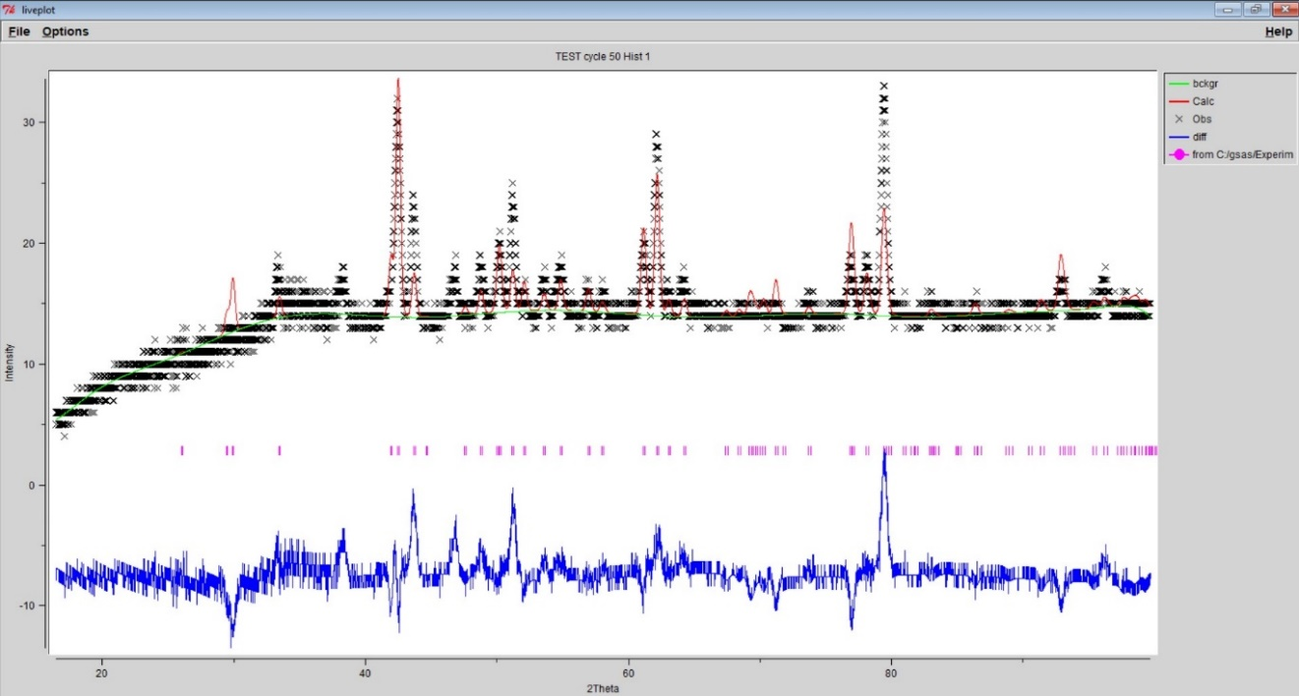
Fig. S1. Micro-focused beam X-ray diffraction pattern of the coexisting bridgmanite in the Iris-1272 experiment. The blue profile in the lower indicates residual difference between experimental and calculation intensities. Thus, a structure factor weighted method was used for the refinement of the lattice parameters.

Text S2. The refinements of the lattice parameters of Bdm in the electron diffraction patterns

An example of the d-spacing measurement in a selected area diffraction pattern along the c-axis of the bridgmanite and the correction by a Si standard.

The measurement of the length of the c-axis in the coexisting bridgmanite was performed in the following procedures.

- To measure the length between 006 spot and 00$\overline{6}$, which corresponds to the d-spacing of (0 0 12) by using the wave length of 200 kV and the camera length of the electron diffraction system. The d-spacing is practically measured by using the reciprocal scale of 10 [1/nm] in the electron diffraction pattern (Fig. S2.1) and an intensity profile along the c-axis (Fig. S2.2). The value of 17.486 [1/nm] is 0.0572 [nm] in the real space.

- The length of the c-axis in the bridgmanite was calculated by 12 times of d-spacing of (0 0 12). The value is 0.6864 nm in the real space.

- The obtained length of the c-axis was corrected by an external silicon standard in the system. The value of the c-axis is corrected as 0.7032 nm.

- The value is 0.269 % smaller than 0.7038916(6) nm (by XRD in Fig. S1).

- The difference can be corrected with an 0.269 % increase (Bdm-c-axis correction, x 1.00260 in the text S3)

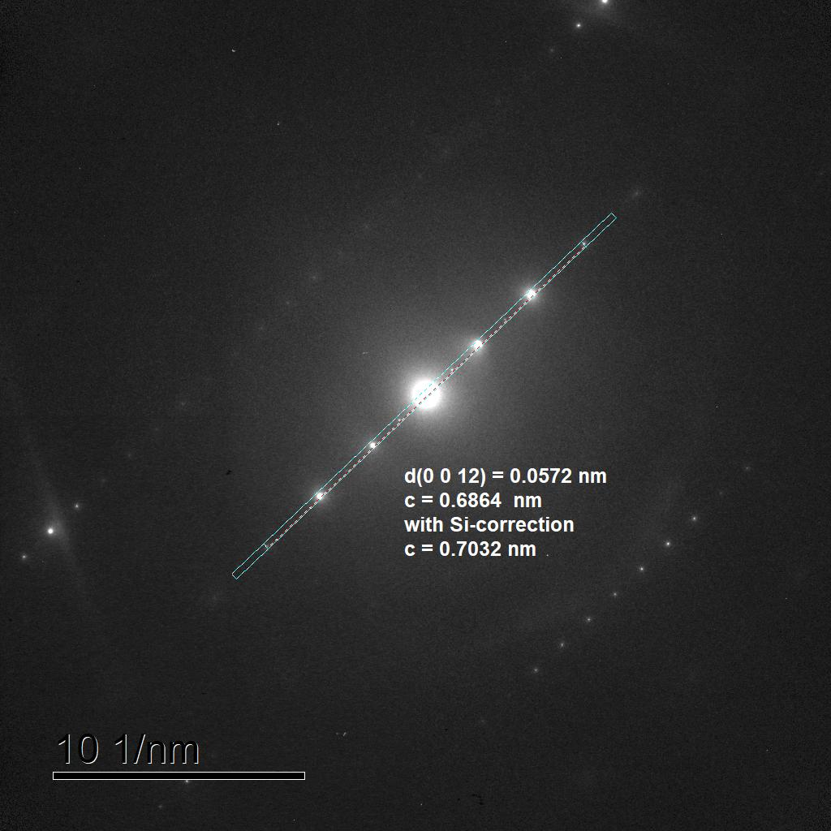
Fig. S2.1. The SAED pattern of a systematic diffraction condition along the c-axis in Bdm. An area profile is integrated to measure the length of the d-spacing of (0 0 12).
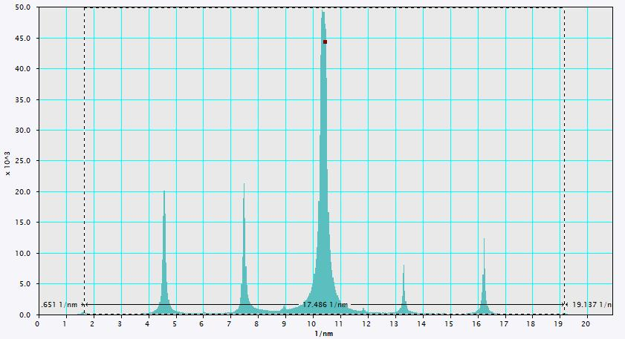Fig. S2.2. Intensity profile along the c-axis of the Bdm (Fig. S2.1).

Text S3.

The refinements of the lattice parameters of Dvm in the electron diffraction patterns

The refinement of the lattice parameter of Dvm was done as the same procedure as that for the length of the c-axis in Bdm. As shown in the Figure S3, the length of d-spacing of (4 0 0) was measured as 0.3476 nm without any Si-standard correction. The value is corrected as 0.356 nm with a Si-standard correction (2.4% increase). Further, as we added 0.2% increases the lattice parameter, whose error is estimated from the difference between XRD data and SAED pattern of Bdm (Run Iris-1272 at BGI), the lattice parameter of the Dvm is a = 0.3569592 nm = 0.357(2) nm. We repeated this procedure in 10 individual d-spacings and averaged the results to calculate a standard deviation in the averaged value, as shown below.

List of the correction factors in evaluating 10 individual d-spacings

- Averaged 10 measurements and the standard deviation (Table S3)
  - 0.3468 nm +/- 0.0004 nm = 0.3468(4) nm

- Si-correction factor is 1.02416571, 1.0242, 2.4% increase.

- Cross-checking by using a micro-focused beam XRD data (Fig. S1) of the Bdm

Increase 0.269 % error/increase (by the Bdm-c-axis correction, x 1.00260)

The final value of the length of the a-axis 0.3561(4) nm

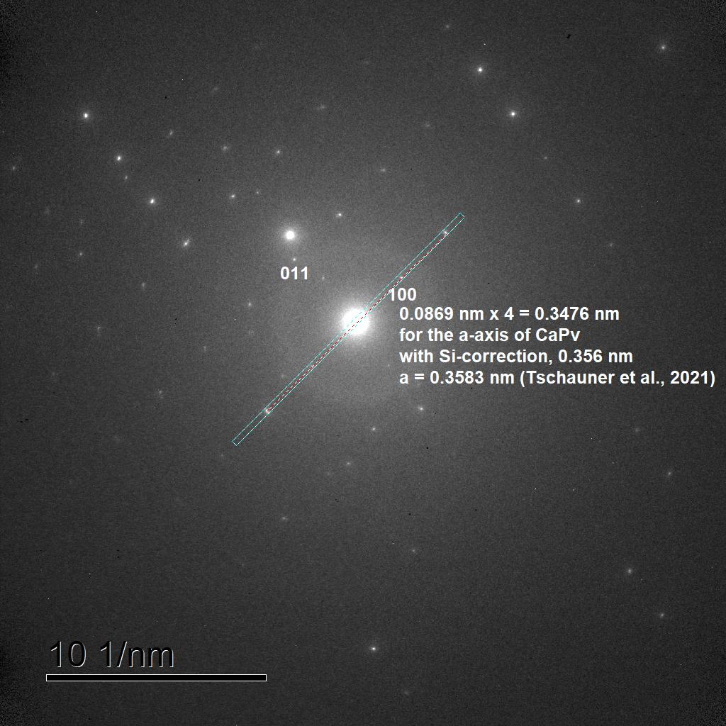
Fig. S3. The SAED pattern along the [0$\overline{1}$1] zone axis in Dvm. An area profile along the a₁-axis of Dvm is integrated to measure the length of the d-spacing of (4 0 0).

Table S1. Averaged 10 individual d(400) spacings and the standard deviation in davemaoite (Dvm).
No. of measurements | Results of 1/d(400), [1/nm] | d(100) = the length of the a-axis [nm] | Remarks**
1 | 11.529 | 0.3470 | NT805 along the [u00] zone axis
2 | 11.553 | 0.3462 | NT806 along the [u00]
3 | 11.516 | 0.3473 | NT805 along the [u11]
4 | 11.548 | 0.3464 | NT805 along the [u22]
5 | 11.529 | 0.3470 | NT806 along the [u00]
6 | 11.537 | 0.3467 | NT806 along the [u11]
7 | 11.547 | 0.3464 | NT806 along the [u22]
8 | 11.534 | 0.3468 | NT806 along the [u33]
9 | 11.534 | 0.3468 | NT809 along the [u00]
10 | 11.514 | 0.3474 | NT809 along the [u11]
Average | 11.5341 | 0.3468
STDV* | 0.0129 | 0.0004
* STDV: standard deviation of the 10 individual measurements. ** The NT80Xs are the indexing numbers of individual diffraction patterns.

Table S2. The volume and molar volume of davemaoite at ambient conditions.
Sources | Volume (V₀)  [A³] | Molar volume  [cm³/mol] | Remarks
This study | 45.16(10)* | 27.19 | Ca_{0.98}Mg_{0.005}Al_{0.03}Si_{0.99}O₃
Wang et al. (1996) | 45.58(4) | 27.45(2) | The end member of CaSiO₃
Tschauner et al. (2021) | 45.88 |  | A natural solid solution** in a meteorite*

* It might be under a residual pressure, ** The composition of the Dvm is (Ca_{0.43(1)}K_{0.20(1)}Na_{0.06}Fe_{0.11(1)}Al_{0.08}Mg_{0.06}Cr_{0.04(2)})(Si_{1.0(2})Al_{0.00(1)})O₃.

Text S4. The symmetry of davemaoite in selected area electron diffraction at ambient pressure. The analysis of the extinction rule of Pm$\overline{3}$m in davemaoite.

The simulation of selected area electron diffraction (SAED) pattern of davemaoite on the assumption of the symmetry of Pm$\overline{3}$m cubic is compared with those of bridgmanite (Space Group, Pbnm) with and without double diffractions. The simulation patterns of the [0$\overline{1}$1] zone axis in Dvm (Fig. S4.1) and the [$\overline{1}$00] zone axis in Bdm (Fig. S4.2) are almost identical except for the differences of the indexing hkl numbers, corresponding to the pattern in the Figure 1b. However, in the latter case for the [$\overline{1}$00] zone axis in Bdm, an experimental SAED pattern of the [$\overline{1}$00] zone axis should display some intensities of diffractions spots with (00l): l = 2n+1 (indicated red circles with yellow margins) due to dynamical diffraction effect (i.e. double diffraction), as shown in Figure S4.3. The complete absence of those spots in the Figure 1b demonstrate that the Figure 1b is from Dvm rather than from Bdm, because of no detectable intensities between diffraction spots with (00l): l = 2n. Also, it is a proof of the extinction rule of Pm$\overline{3}$m cubic symmetry for davemaoite.

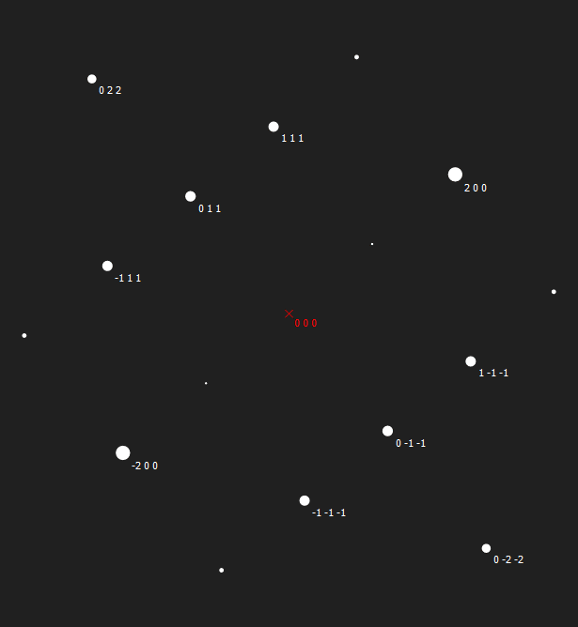
Fig. S4.1. Kinematical SAED pattern simulation along the [0$\overline{1}$1] zone axis in Dvm.

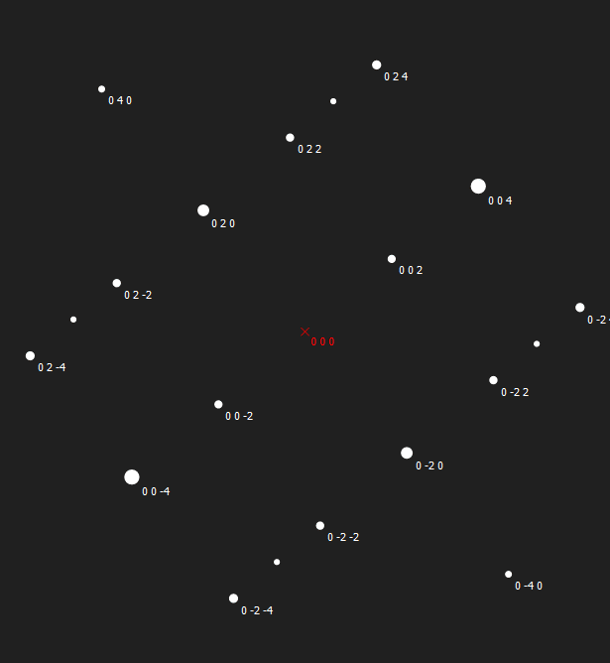
Fig. S4.2. Kinematical SAED pattern simulation along the [$\overline{1}$00] zone axis in Bdm.

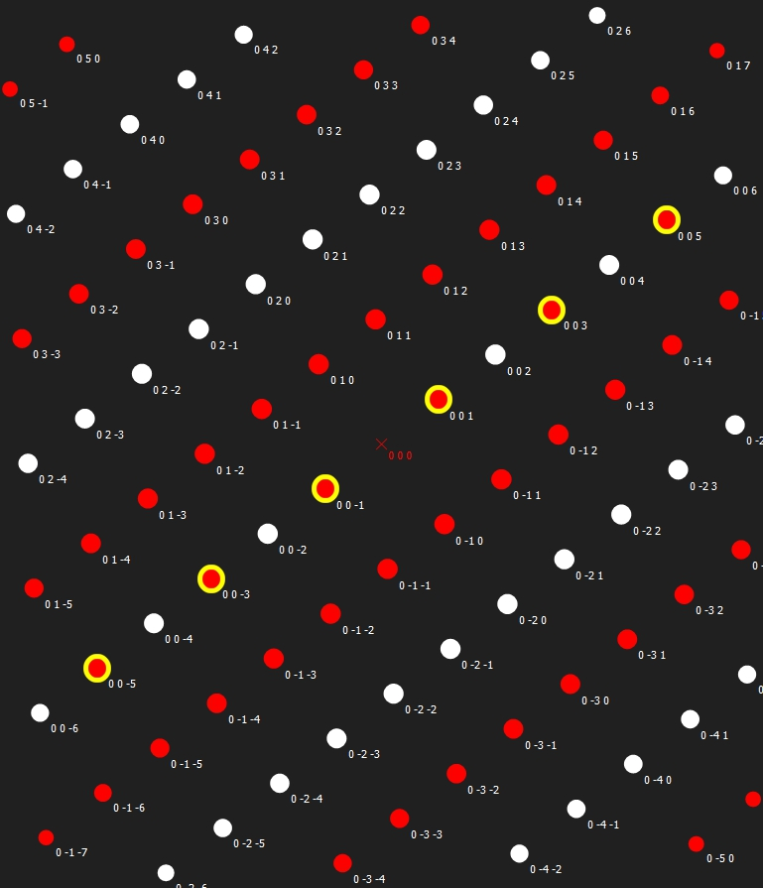
Fig. S4.3. SAED pattern simulation along the [$\overline{1}$00] zone axis in Bdm. The diffractions spots (indicated red circles with yellow margins) with (00l): l = 2n+1 are detectable in experimental diffraction pattern along the [$\overline{1}$00] direction due to double diffractions, although the diffraction spots with (0kl): k = 2n+1 (also indicated red circles) are forbidden even if double diffraction occurs.

Text S5. A HAADF-STEM image of crystalline domains of Dvm and the surrounding 3-demension framework of the crystalline Bdm grains in the Iris-1272 sample.

A HAADF images display crystalline domains of Dvm. The white contrast grains are crystalline Bdm grains, which construct a framework in 3-demension. The ridged framework supports a pressure generated from volume expansion in the transition from Dvm to the amorphous state and prevents the complete amorphization of Dvm.

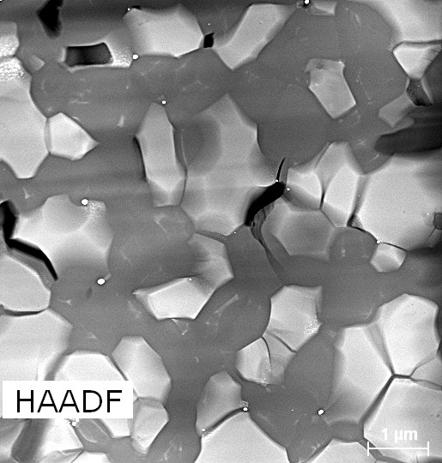
Bdm
Bdm
Bdm
Bdm
Bdm
Bdm
Bdm

Fig. S5. A HAADF-STEM image showing crystalline domains of Dvm (e.g., one domain indicated by the black arrowhead). The ridged 3-demension framework of the crystalline Bdm grains (white grains) support an inner stress/ a pressure in amorphous CaSiO₃ materials containing the crystalline Dvm domains.

Text S6. The estimation of a residual pressure in the recovered sample from the high-pressure experiment (Iris-1272).

1. The estimation of the residue pressure remained in the Dvm based on the decompression data of Dvm (Wang et al., 1996).

The residue pressure remained in the dvm was estimated based on the EOS of dvm and from the difference of V₀ between 45.576 Å³ (Wang et al., 1996) and 45.16(10) Å³ (This study) based on their data. The direct difference is 0.912 %, but as shown in the following plot (Pressure vs volume) in Fig. S6, residual pressure remained in our Dvm-bearing aggregate is about 1.2 GPa corresponding (45.282-45.16) / 45.282 = 0.269 % difference in volume.

2. The other estimation of the residue pressure from the density difference between amorphous glass and Dvm crystal (~33 %).

We cannot estimate a reliable residue pressure only from the density difference between amorphous glass and Dvm crystal, because we do not know how much ratio of Dvm and amorphous glass were at the pressure release and how rigid of the surrounding Bdm aggregate is to support an internal pressure laterally.

3. In comparison of the above-mentioned two estimations.
The ratio of the two estimations is 0.269 % / 33 % = 0.00816. The sample could support few stresses generated in the transition.

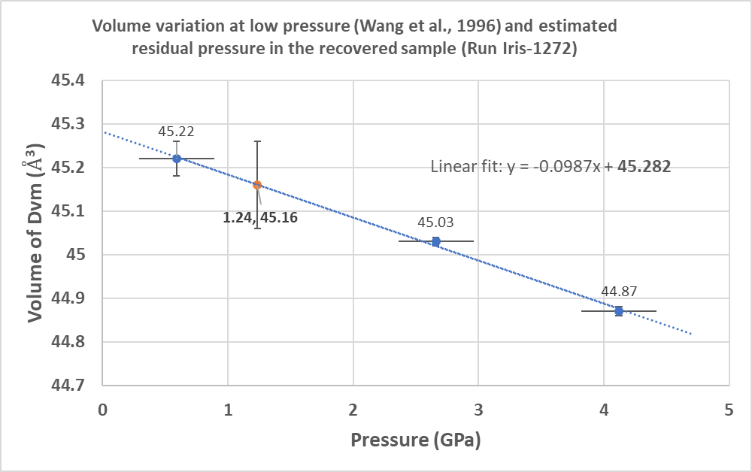
Fig. S6. The estimation of a residual pressure in the recovered sample (Run Iris-1272) based on the volume variations of Dvm in a function of pressure. The blue circle data, the numbers are volumes, is from Run 13 in Table 1 (Wang et al.,1996). On the assumption of the V₀ = 45.282 (Å³) in a linear fitting on the data, a residual pressure of about 1.2 GPa can be estimated from the measured volume of 45.16(10) (Å³) in this study, plotted as an orange circle.

References

Nakatsuka, A., Fukui, H., Kamada, S., Hirao, N., Ohkawa, M., Sugiyama, K., & Yoshino, T. (2021). Incorporation mechanism of Fe and Al into bridgmanite in a subducting mid-ocean ridge basalt and its crystal chemistry. Scientific Reports, 11(1). <Go to ISI>://WOS:000722365800014

